**3-D Block Letters**

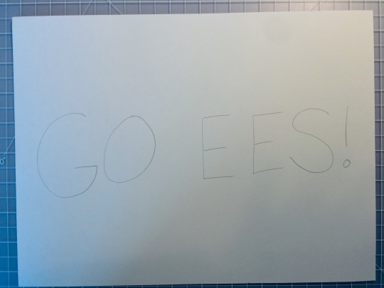 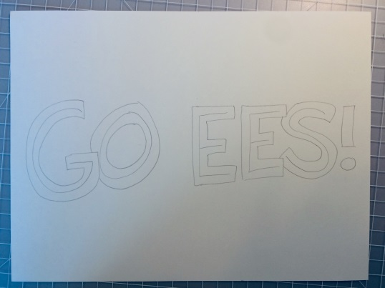

**Write your letter, word or words Outline around your letters**

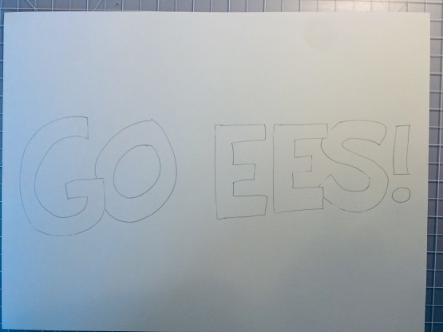 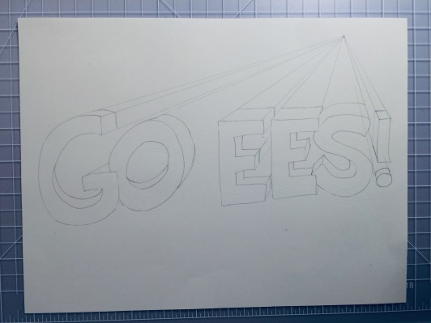

Make a dot somewhere above or below your words for a vantage point; use a ruler to draw a line connecting all the corners of the letters to the dot; draw sides of letters, they can stretch all the way to the vantage point, or you can cut them off shorter.

**Erase your original lines Make a dot for a vantage point; use**

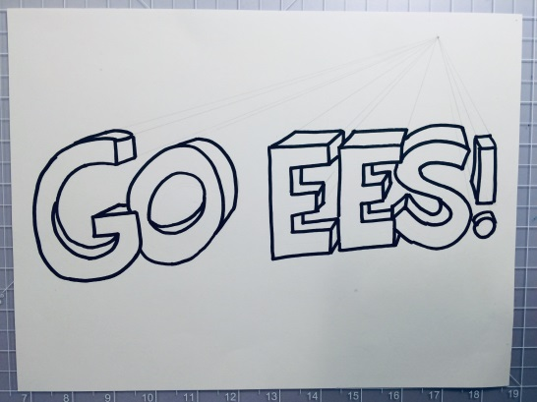 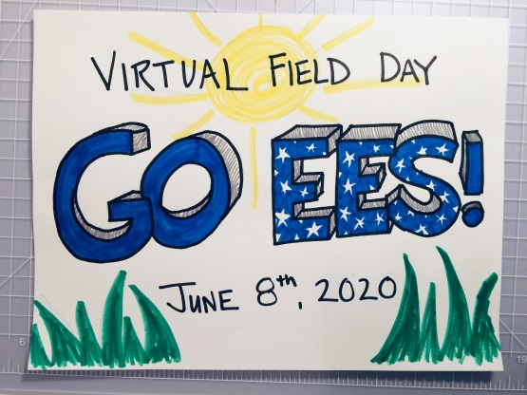

**Outline letters with marker and erase extra lines Color letters, add interesting details**