Color Wheel Collage
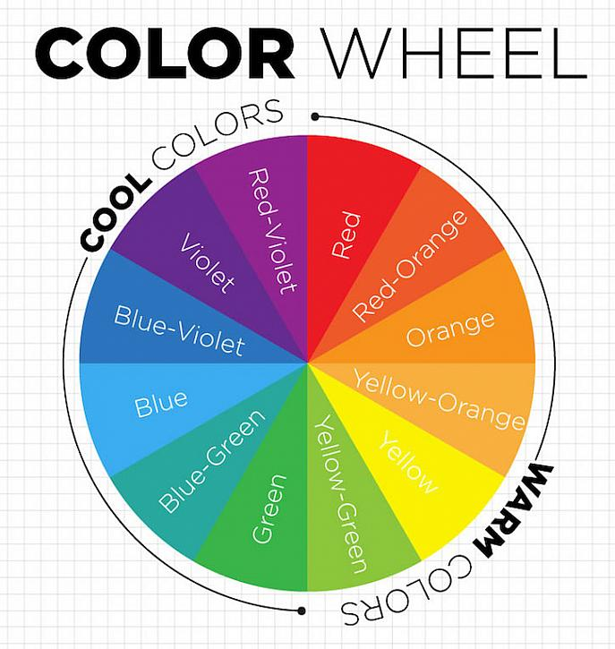
Materials:
- White paper
- A kitchen plate or large circle to trace
- Pencil
- Ruler
- Glue stick
- Colored scraps of paper or flat items that can be glued to paper
Steps:
- Find a few examples of each color on the color wheel around your house. The recycling bin is a great place to look, also magazines, junk mail, food packaging, wrapping paper, ribbons, bows, covers of old coloring books or calendars, boxes in the garage or pantry. Just make sure to ask before cutting anything that isn’t yours.
- Trace a dinner plate on a piece of white paper and divide it into 6 equal slices. Start by putting a dot in the center of your circle and drawing a line directly down the center, then break each half up into 3 slices. Be sure to line your ruler up with the center dot each time you draw a new line.
- Write the name of each color on each of the slices before you start gluing so you have a guide.
- Using the color wheel above as a guide, pick a slice and color to start with and begin cutting and pasting your papers onto your wheel. Make sure to overlap your pieces and fill in the whole circle so that no white is showing. One color should fade into the next, with the tertiary colors blending in between each primary and secondary.

