Drawing a Landscape in 1 Point Perspective
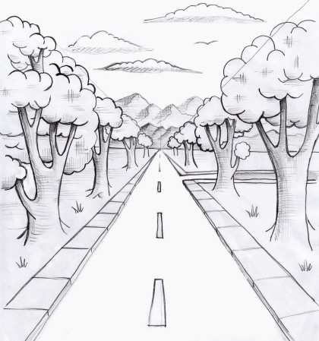
Materials: Paper, Pencil, Ruler, Crayons, Colored Pencils or Markers
Steps:
- Scroll through the gallery of pictures showing 1 Point Perspective and notice how the objects decrease in size as they get further away from the viewer.
- Using a pencil and ruler, draw a horizon line horizontally across the center of your paper.
- Make an X from the upper left corner to the bottom right corner, then from the upper right corner to the bottom left corner. These lines should cross in the center of your horizon line.
- Beginning on the left side of the page, draw a row of trees rooted on the diagonal line of the bottom left quadrant, with the tops of the trees roughly following the diagonal line of the upper left quadrant. The trees should decrease in size as they reach the center of the X. This is the vanishing point of the piece.
- Repeat step 4 on the right side of the page.
- Add detail to the bottom center portion of the page. You may choose to make it a road with sidewalks on either side, or a river with rocky banks on either side.
- Add detail to the focal point area of the piece, like a setting sun or a moon, or a mountain range in the distance with clouds above.
- Finish the piece by adding color.

