Marcus Oakley: Art from Cardboard

Materials: Cardboard; a box cutter; paint; glue

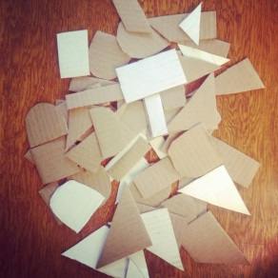
- Break down a cardboard box and cut it into squares and rectangles along the folds, then cut those pieces into smaller geometric shapes. Make sure to save one big square or rectangle for your canvas.
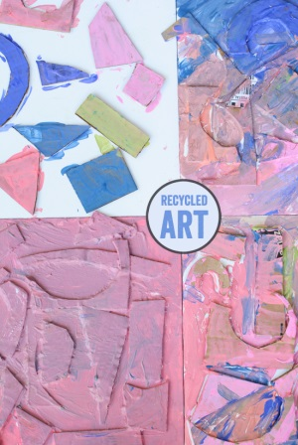
- Use colorful tempera or acrylic paints to paint all your shapes. Paint your big canvas piece white.
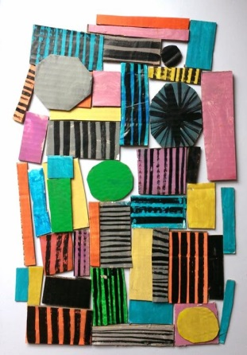
- Once your pieces are dry, arrange them on your white canvas background the way you like them. Feel free to overlap and stack shapes on top of each other. Make sure to use plenty of glue. Last, use black sharpie marker to add details like lines or geometric patterns on top.

