Tracing Shadows
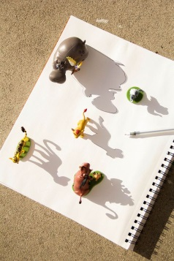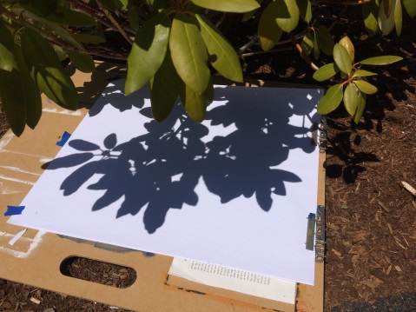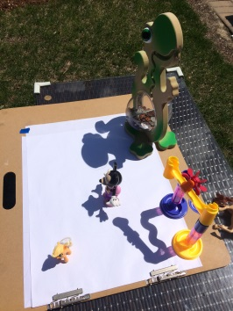
Materials:
- White paper
- Pencil
- Black sharpie (optional)
- Sunshine or a strong flashlight in a dark room
- Paint, markers, crayons colored pencil, ball point pen. Any color medium of your choice.
Steps:
- Gather some objects from your house that might cast some interesting shadows. Things like houseplants, bottles, trophies, kid’s figurines, toys work great. You’ll want things that stand tall vertically. Or, if you’re more interested in organic shapes and a natural looking result, look around your yard for interesting shadows being cast by trees, shrubs and flowers.
- If weather permits, sunlight is your best option for creating the shadows. Arrange your objects on the paper so that the shadow shapes fill the page, and begin tracing. Wind can be frustrating, but remember the images do not have to be traced perfectly. It will come out cool no matter how off your lines may get. If you need to create a shadow inside, the flashlight on most cell phones works great. You will need to prop it up inside a cup with the beam just above the rim of the cup (or use a tripod if you have one) and raise it up to the level you need by stacking books or some other flat sturdy surface. I used this technique for my Clorox bottle painting and it worked great.
- Once you are happy with your composition, fill it in with color. Use whatever medium you have on hand. The link I have provided on color theory is a great resource for considering color relationships that work well together.
