Field of Dandelions
Grade 3
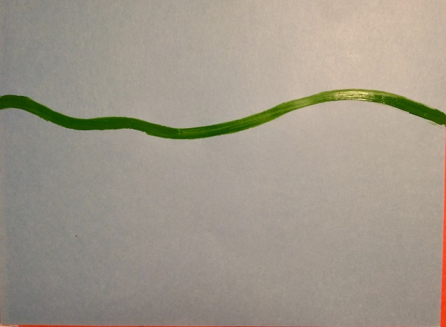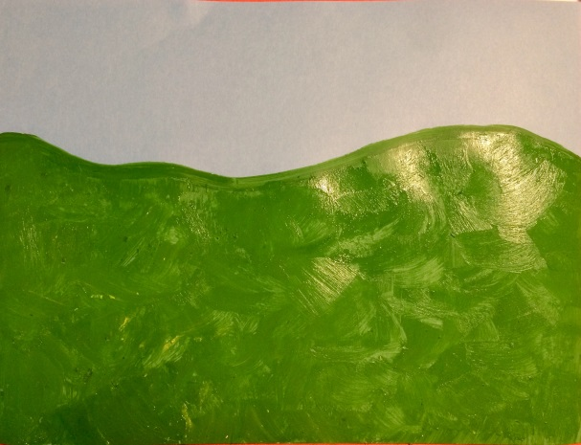
Draw Horizon Line Fill In Ground With Color

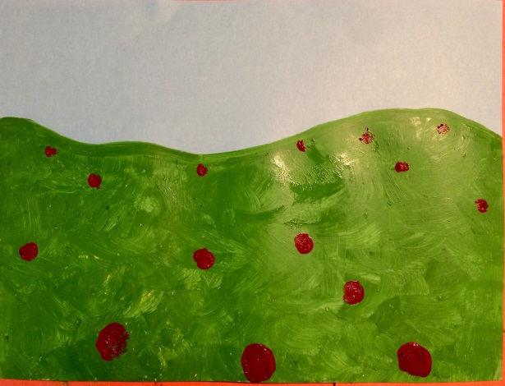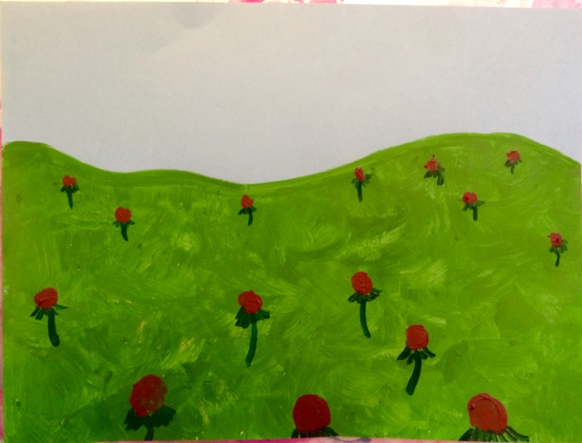
Draw Centers of Flowers, Big in Foreground Add “Skirts” and Stems to the Flowers
Small in Background
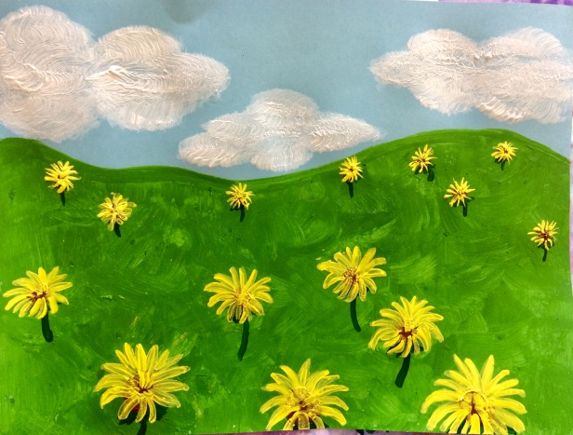
Add yellow petals with a detail brush, or white dots with a Q-tip or your pinky finger if you want to show flowers that have gone to seed.
Add details to sky like clouds, sun, birds

