Create your own version of Claude Monet’s “Waterlilies” Grades 2 / 3
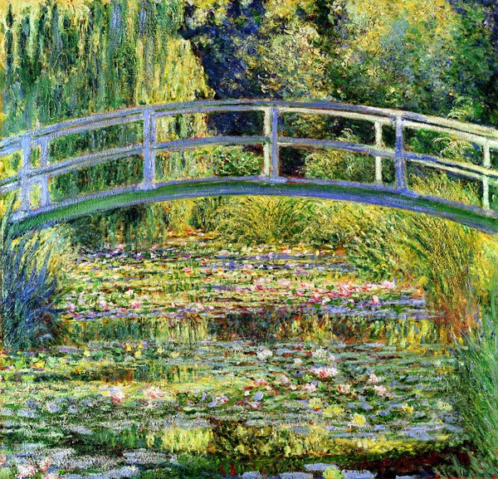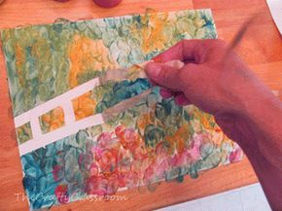
Materials:
Pencil
Paper (the thicker the better)
Masking Tape (or any kind of tape?)
Paints or Crayons

Steps:
- Using your pencil, draw to two horizontal arched lines (frowns) one on top of the other, across the entire page to create the top and bottom of the bridge. Then draw vertical lines from one arch to the other to create the bridge railings.
- Tear off two long pieces of tape. Put one on top of each of the arches you drew, then tear smaller pieces to place over your vertical railings. Make sure to push the tape down firmly. The arched pieces will have bumps in them because you’ll have to make them curve. Don’t let this frustrate you!
- Use cool colors-blues, purples and greens to fill in the water underneath the bridge. If you are using paints, you can either use your fingers as brushes, or a paintbrush. Whichever you prefer. Make sure to use loose, fluid strokes to show the movement of the water. Make sure to overlap your strokes and fill in the whole area so that there is no white showing. Go right up to the edge of your tape, it’s ok to cover the tape areas too.
- Use greens, oranges and yellows to fill in the foliage above the bridge, and vertical green strokes/lines to show the grasses growing up around the edge of the pond.
- Use warm colors-pinks, oranges, yellows and reds to “dab” the waterlilies on top of the surface of the water
- As a final touch you can dab some white paint around here and there to show the light reflecting on the water.
- Carefully remove the tape to reveal your bridge.

Tips:
*Make sure to cover the whole page so there is no blank paper showing.
*Go right up to the edge of the tape, it’s ok to paint or color on top of the tape.
*Have an adult help you remove the tape if your paper starts to tear.

