Summer Self Portraits
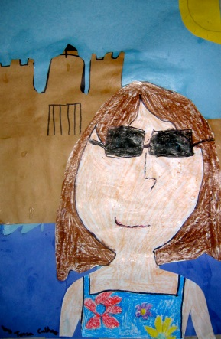
Materials: 2 pieces of construction or drawing paper; a pencil; crayons or markers, a mirror.
Creating the beach background
- Divide your first piece of paper in 3rds vertically. The bottom section will be the sand, the middle section will be the water and the top section will be the sky. Or, if you want to be swimming in the water for your selfie, like the example above, the bottom will be the water, the middle the sand and the top the sky.
- You can color your sections in with crayon, paint them, or cut out and glue colored construction paper to your paper. Remember that the horizon line where your water meets the sky will be straight, and the line where the water meets the sand will be wavy. The water should be dark blue or green, the sand light brown or beige, and the sky light blue.
Creating the self portrait
- On your second piece of paper, start by drawing an oval shape for your head. Use your mirror to see what kind of shape your head is. Then two straight lines for your neck. If you’d like to show your shoulders, draw two curved lines extending from your neck going right off the bottom edge of the paper.
- Starting half way down your oval, add football shapes for your eyes. They should line up with your ears, which you will draw by making two curved lines on either side of your head. To finish your eyes, draw a circle in the middle of the football shape, this will be the iris of your eye. The part that has your eye color. In the center of the iris is a black pupil. And don’t forget eyelashes. Boys have eyelashes too!
- Next add nose and mouth. Noses can be tricky. Use the handout to see some options.
- Now add eyebrows and hair. If you have room to add a beach hat, go ahead and do that now too.
- If you can see your shoulders and the top of your torso, you can draw your favorite bathing suit or water shirt.
- When all your details are drawn, outline everything with black marker, then use crayons to color in your drawing. Make sure to use the appropriate skin tone to color in your face, neck, ears and shoulders.
Putting it all together
- Next, cut your drawing out and glue it on top of the beach background you created.
- Last, add details like waves and fish to the water; a sandcastle or beach toys, umbrellas, chairs, etc. to the sand; the sun, clouds, birds to the sky.

