Tracing Overlapping Shapes
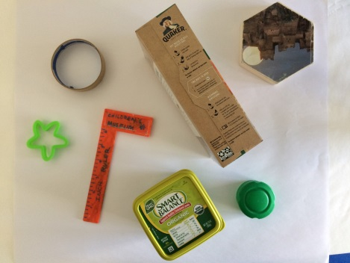
Materials:
- Paper
- Pencil
- Black Marker (not essential)
- Traceable household items (you could trace the same item over and over, or as many different objects as you want)
- Crayons, markers, paint, colored pencils (whatever you have to add color)
Steps:
- Hunt around your house to find some interesting traceable items. Look for geometric shapes with hard corners and sides that will be easy to trace with a pencil. Also think about what you will be using as a coloring medium. If you will be using markers, for example, stick to smaller items that won’t tire you out to color in (or use up your whole marker). If you will be painting, bigger items will be better.
- Lay your items out on the paper and arrange them how you like, then carefully trace around each item. Once everything has been traced, move each item around to a new spot making sure that each shape is overlapped at least once.
- If you have a sharpie, outline all your pencil marks and erase any stray marks.
- Now, using the medium of your choice, add color to each of the different shapes you have created. Grades 3-5 should use the color theory reference link to try out different color relationships. Depending on how “busy” your composition is, you may want to choose a new color for the negative background space.

